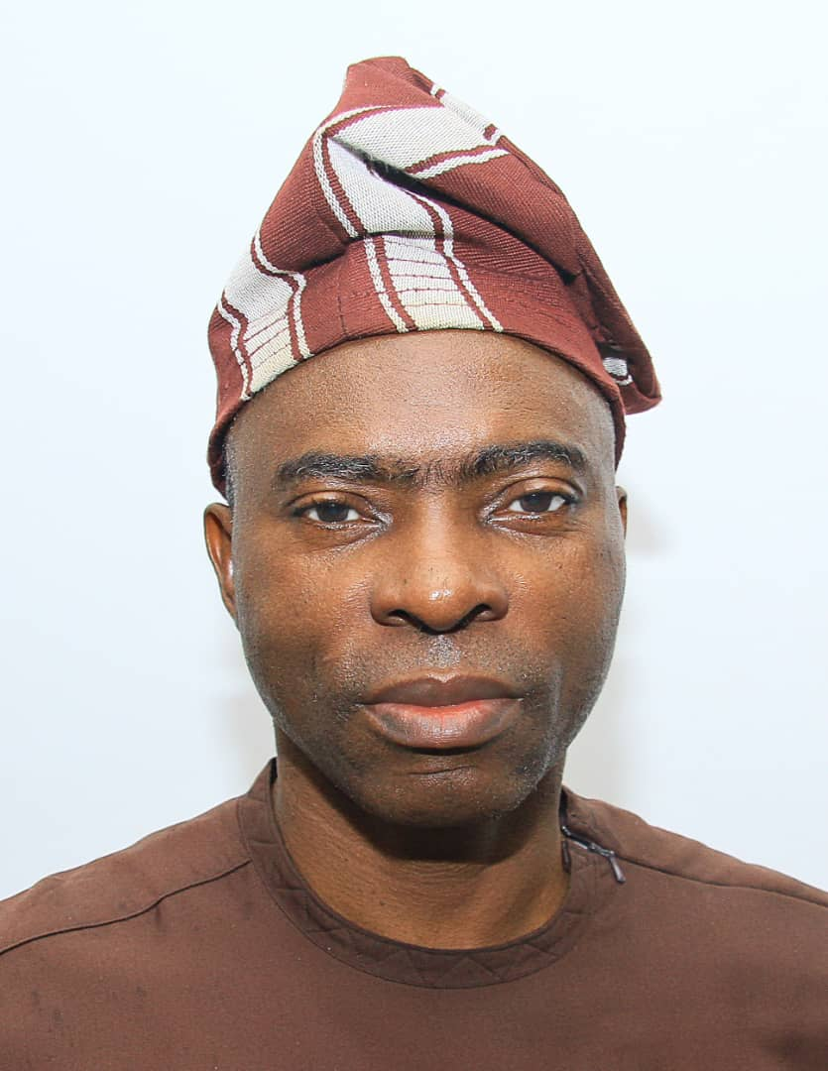

**MR. GODSON NWANKWO, CHAIRMAN, CREDIT COMMITTEE**